Autonomous Car Parking
Author: Gabriel Almeida
[gabriel.c94@gmail.com]
Czech Technical University in Prague, Department of Measurement
March 27th 2017

Introduction:
With the increasing number of cars in our streets, the amount of crashes and accidents caused by human errors only grows. This brings the necessity to automate not only driving, but parking also, most drivers have difficulty with parallel parking, which is the type of parking that this project proposes to solve.

The prototype:
For the development of this project, a remote controlled car has been modified to serve as a prototype, it consists of a frame with 4 wheels, 1 dc motor, and a servo. The dc motor drives the two back wheels, and the servo is used to steer the car front wheels. Two inductive proximity sensors and three ultrasonic sensors were also added to the car frame, the inductive proximity sensors are used to measure the wheel’s speed and the ultrasonic sensor to detect surrounding objects.
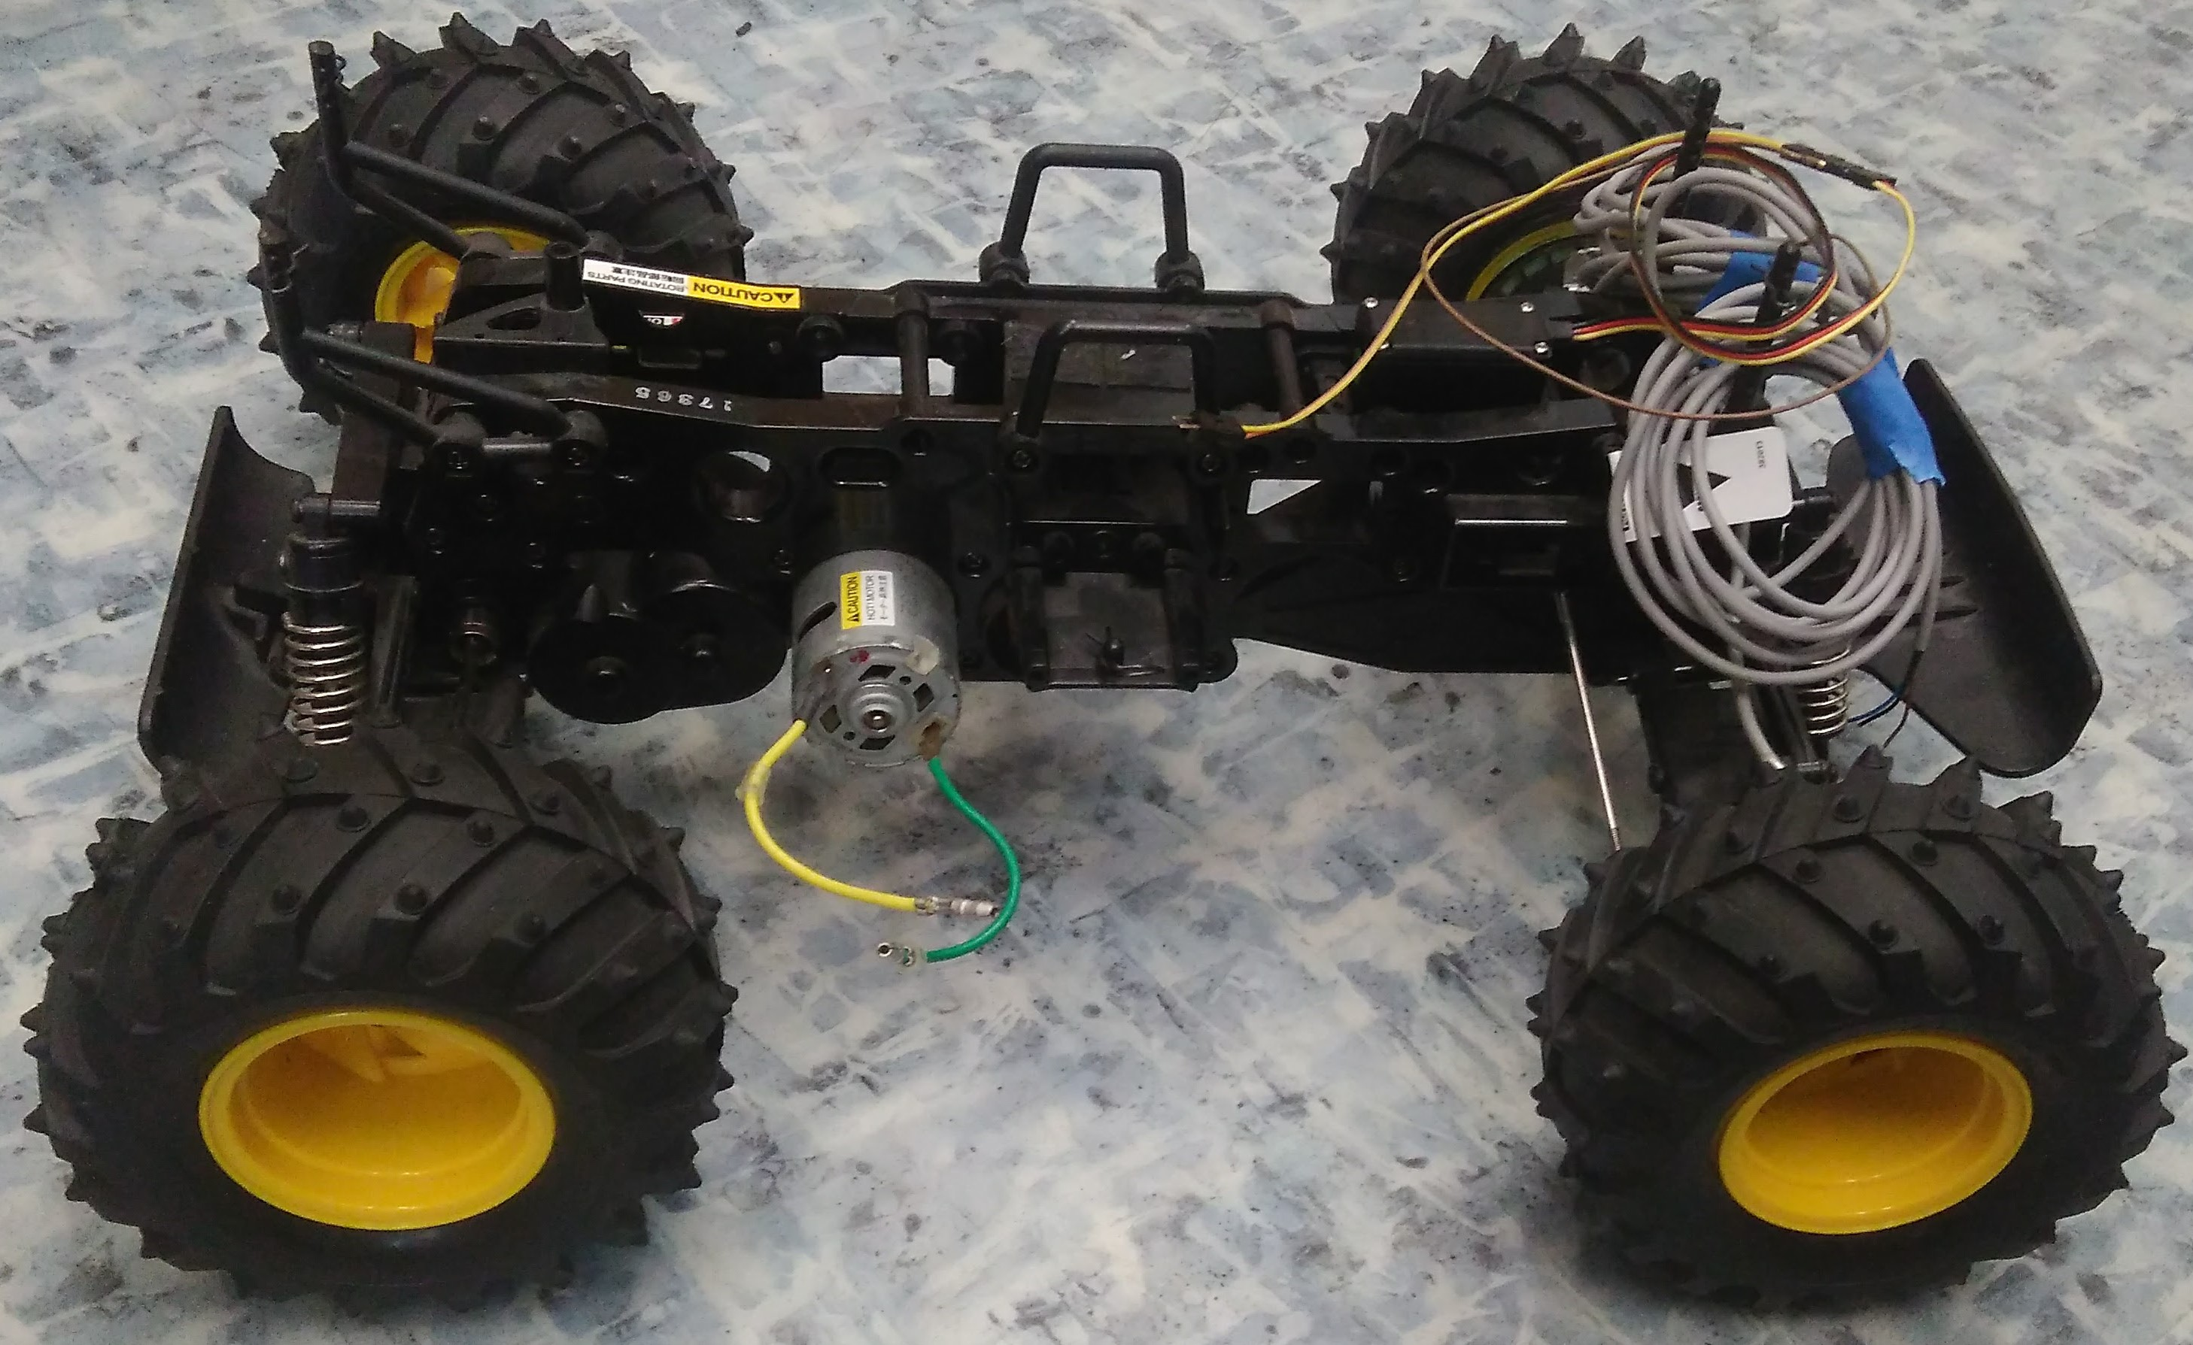
Illustration 1: The remote control car used

Desired behavior:
The parking of the car consists proposed in this project consists of two parts, finding and measuring the possible parking spot and parking the car in the spot found. To find the parking spot, the car is programmed the go forward in a straight line, using its side sensor to detect if there are cars present there or not, when there is no car present it starts to count for how long there will be no more cars, and with the speed measured it calculates how big the parking spot is. If the parking spot is big enough, it starts the parking algorithm, if not, it continues going forward looking for another parking spot.

Hardware:
- DC motor
- Servo
- 3 Ultrasonic sensors
- 2 Inductive proximity sensors
- Breadboard
- H-bridge
- Arduino Mega ADK

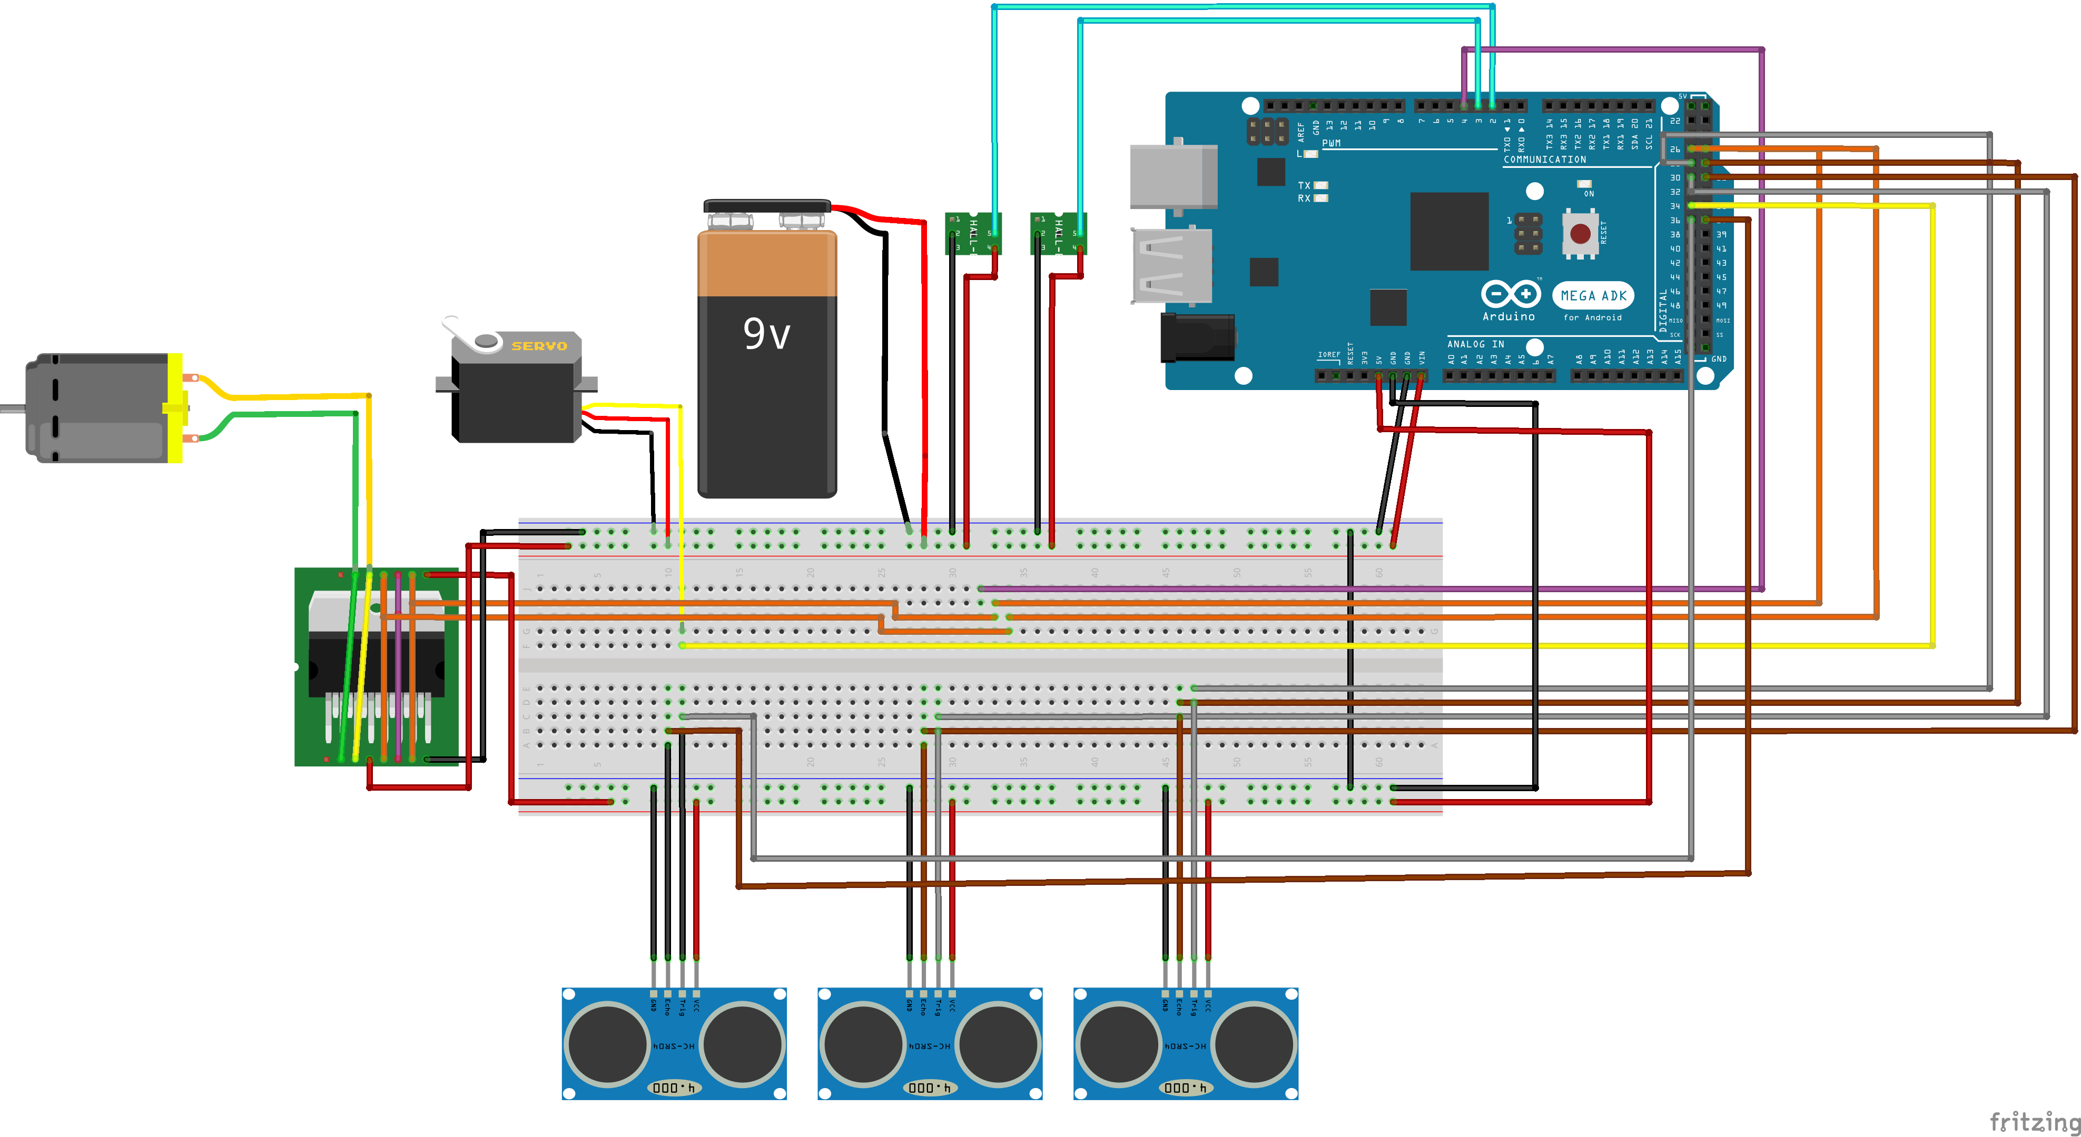
Illustration 2: Project's full schematics

Ultrasonic sensors:
These sensors works by sending an ultrasonic wave and hearing for its echo, the distance is calculated from the time delta from when the wave is sent to when its echo is heard, it was used the NewPing library to use this sensor more easily to measure the object’s distance.

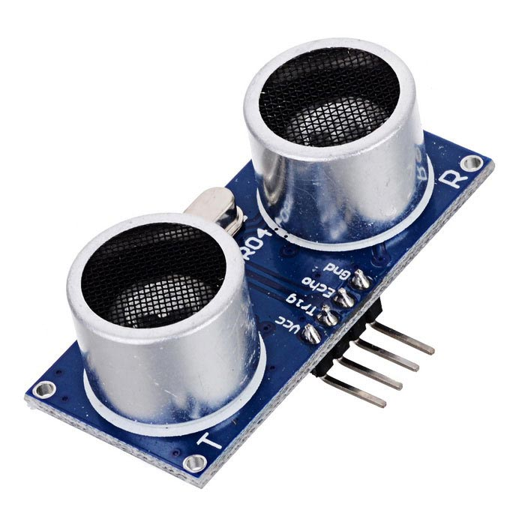
Illustration 3: Ultrasonic sensor

Inductive proximity sensors:
These sensors works by creating an electromagnetic field in front of it, if any metal is in a short distance in front of it, it will disturb the electromagnetic field and thus be detected, this sensor is used together with a metal disc with 20 holes, attached to each one of the wheels, so whenever the car wheel spins, the gaps in the disc will pass in front of the sensor, which makes it possible to tell how many 1/20 of turns the wheel has made, and this information is used to calculate the car speed.
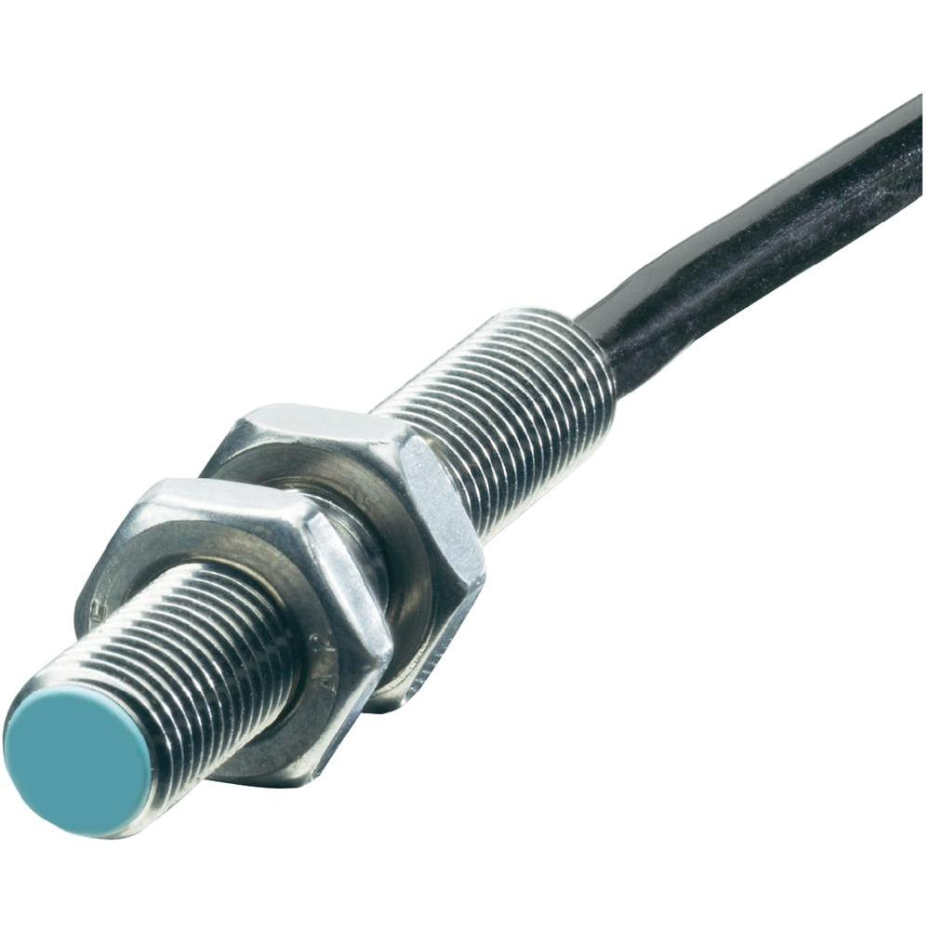
Illustration 4: Inductive proximity sensor

H-bridge:
The h-bridge is used deliver power and to control the rotation direction of the motor, whether it goes forward or backwards, the one used in this project was the L298N, the h-bridge logic power is supplied by the arduino, while the power passed to the motor comes from the main battery itself. This bridge can drive two motors at 2A each, but as our motor might draw more current than that, the bridge was connected in a parallel configuration, so it can drive one motor at 4A, to do this, it is needed to short the following pair of pins: IN1 and IN4, IN2 and IN3, ENA and ENB, OUT1 and OUT4, OUT2 and OUT3, as shown in the project schematics.
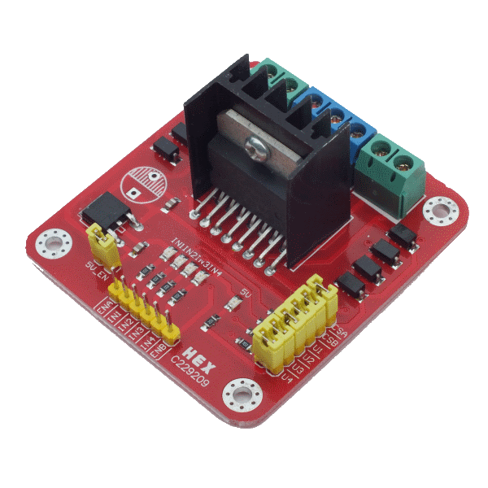
Illustration 5: H-bridge L298N

Servo:
The servo is used to control the car steering, its usage is very straight forward, it is supplied by the main battery directly, and one of its pins connects to the Arduino, which sends the desired angle to the servo, to do this more easily the Servo library was used, to more easily control it.
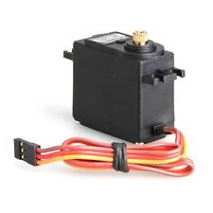
Illustration 6: Servo

The driving straight problem:
One of the main problems in this project was making the car drive in a straight line, it is the same problem when driving a normal car, you see with your eyes the even though your are holding the steering wheel in a fixed position, the car might be going a little to the left or to the right, due to many reasons. In this small prototype, the problem is even worse, because the wheels are hard to keep aligned, any weight added to any side of the car deeply affects it, and the servo position control is not as precise as needed. Even faced with all this problems, a solution was implemented to deal with it, the rotation of each of the wheels are measured individually, if one wheel is spinning faster than the other, the car slightly corrects the servo angle, using a proportional control. The implemented solution doesn’t work well, because when the car is on very wide turns, the wheel rotation difference isn’t detected, because the metal disc only have 20 holes in it.
For example, lets take a 4 meters radius turn, which already affects the straight trajectory too much even in small distances, given that the car roughly 0.3 meters wide, the inner wheel will make a 3.7 m turn. To keep the car on track, we need to correct its path constantly, in this project, the rotation difference is measured every 0.5 seconds. So, the car is making a 4m turn, which has a circumference of 8π which is around 25.12m and the inner circumference of 23.23m, if we try to correct the car after a portion of the turn, lets say 40°, the outer wheel would have turned 2.79m, and the inner wheel 2.58m, but the wheel size is around 0.4m, so both sensors would have said that their wheels turned 6 times, and the algorithm wouldn’t try to correct the car trajectory, and that happens when we are trying to correct its trajectory after it already went 40° of the curve, if we try to correct this earlier the difference is even smaller and won’t be noticed also.
To be able to solve this problem, more accurate sensors are needed, with this same approach, a disc with more holes would be needed along with a sensor that could detect those very tiny holes in it.

Algorithm:
The implemented code is broken down as much as possible into small functions, each with a unique purpose, all the code is commented for easier understanding, the main program is divided into two parts, detect the parking spot and park the car.

Detecting the parking spot:
The whole program is started by the press of a button on the breadboard, when the program is started it calls the function to find the parking spot( findAndPark() ), it makes the car go forward checking with the side ultrasonic sensor that there is no free space on its side, as soon as it detect the there is no obstacles in its side, it records the time and keeps going forward, until another obstacle is found, then it takes the difference from the time in that moment with the previous recorded time, with this time delta and the speed measured by the sensors it calculates the size of the parking spot, if it is large enough it will start the parking function, if not, it will start this same function again.
Parking the car:
When a large enough parking spot is found, the car parking function( sensoredParalelPark() ) is called, this function steers the wheel all the way to the right and makes the car go backwards until no obstacle in detected by the side sensor, then it steers the wheel all the way to the left and continues going backwards, until the back sensors detects the car in the back is closer than 12cm from it, the it turns the wheel again all the way to the right to adjust the car going forward, after the car is adjusted, it goes forward until the front sensor detect that the front car is less than 20cm from it, then the parking is finished.
Measuring speed:
The speed measurement in the car is made by the inductive proximity sensors, every time the wheel spins 1/20 of a turn, one of the little metal parts pass through the sensor, which is connected to an interrupt pin in the Arduino, this triggers an interruption routine that increments a counter by one. On top of that, there is an interruption routine programmed to be called every 0.5 seconds, this routines checks how many one one twentieth of spin has been since the last time it was checked, then it calculates the speed based on that, resetting the spin counter to zero for the next call. The routine called every 0.5 seconds is the same routine used to check the difference between the wheels rotations to correct the car trajectory if needed.

